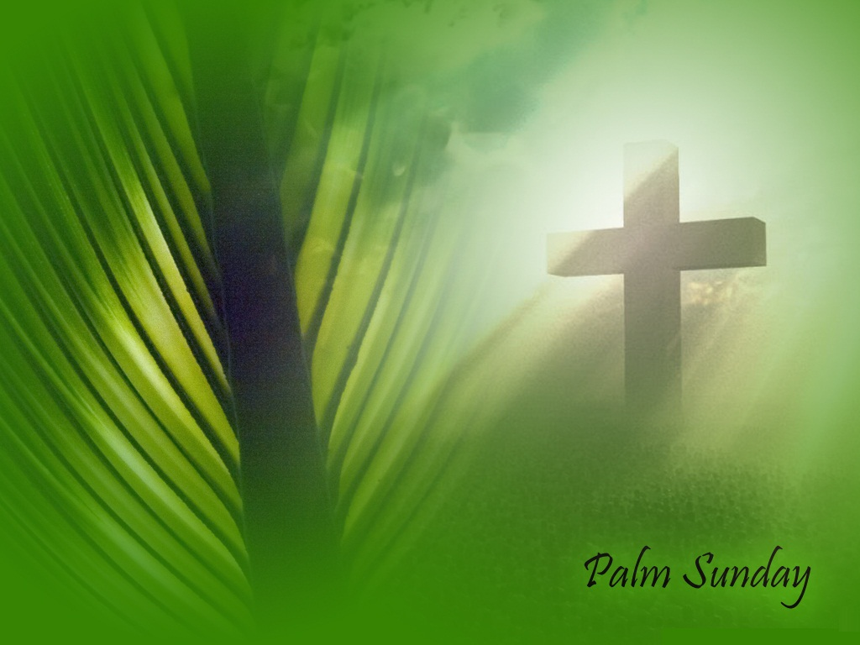
The Why of Palm Sunday

“But now apart from the law the righteousness of God has been made known, to which the Law and the Prophets testify. This righteousness is given through faith in Jesus Christ to all who believe. There is no difference between Jew and Gentile, for all have sinned and fall short of the glory of God, and all are justified freely by his grace through the redemption that came by Christ Jesus. God presented Christ as a sacrifice of atonement, through the shedding of his blood—to be received by faith. He did this to demonstrate his righteousness, because in his forbearance he had left the sins committed beforehand unpunished—he did it to demonstrate his righteousness at the present time, so as to be just and the one who justifies those who have faith in Jesus” Romans 3:21-26.

Today is Palm Sunday which marks the beginning of Passion Week or Holy Week. This is a time when we, as Christians, pause to remember the passion of our Lord Jesus Christ as He went to the cross as the Holy Lamb of God, to be sacrificed as the final Passover lamb under the Law of God, in order to pay the full penalty for our sins. Hebrews 9:22 reminds us, “For without the shedding of blood, there is no remission of sin.”

The Apostle John writing to the church in 1 John 2:1-2, “My dear children, I write this to you so that you will not sin. But if anybody does sin, we have an advocate with the Father – Jesus Christ, the Righteous One. He is the atoning sacrifice for our sins, and not only for ours but also for the sins of the whole world.”

Palm Sunday begins the final days of Jesus’ earthly ministry as He triumphantly enters the Holy City of Jerusalem for one last time - before His trial, crucifixion and resurrection. Jesus had come to save the lost and now was the time that God the Father had ordained to secure our salvation through the passion of Christ.

The word “passion” is a unique and powerful word. As a noun in English, it means “strong and barely controllable emotion,” which is the way it is used to describe God’s passion for you. However, in Scripture, in Greek and biblical Hebrew, “passion” means “to carry a heavy load, a great weight,” “to bear a burden,” “a duty beyond measure,” “a suffering that cannot be escaped, like a room with no exit.” In Latin it means “squeezed and strangled.” This is the Jewish understanding of “passion” and that is what Jesus carried into Jerusalem that day as he bore the weight of God and the burden of sorrow to pay the price for our sins and purchase our salvation. In 2 Corinthians 5:21 Paul writes, “For our sake he [God] made him [Jesus] to be sin who knew no sin, so that in him we might become the righteousness of God.” This is the “Hosanna of God!”

This is what God’s passion for you looks like! Let me ask you, “What does God think about when He thinks about you?” When God meditates on you in His heart, what does He feel? When God focuses His eyes on your soul – and He does - what does He see? When God opens His mouth to speak of you, what does He say? Have you ever stopped to ponder the wonder of these questions? If not, you should, because God does all of this with great passion. What if I were to tell you that when God thinks about you, feels for you, and sees you, He opens His mouth and sings with inexpressible joy for you!

What if I were to tell you that God's love for you is so infinitely intense and the depth of His affection for you is such that mere words are inadequate to describe it? Yes, I am talking about you! I'm talking about each and every one of you who is convinced that no matter how many times you are told God loves you, you still imagine that God must have someone else in mind.
You may be saying, “But Pastor Chuck, you’ve never been around when I've failed, asked forgiveness and then failed again 10 seconds later. You don't know how poor a person I've been or can be.”
But I don't need to know you. I need to know only God! The issue here isn't who you are or what you've done or what you think about yourself. It's strictly a matter of who God is—of His character and His pure determination to love you. Just you! Nothing else matters. You are always on God’s mind and I can prove it – Psalm 139:17-18, “How precious are Your thoughts about me, O God. They cannot be numbered! They outnumber the grains of sand! And when I wake up You are still with me.”
Let me show you a verse that God reminded me of Wednesday afternoon just to prove all that I have said is true and I believe with all my heart God gave it to me just for you:

Zephaniah 3:17, "The Lord your God is with you; He is mighty to save. He will take great delight in you, He will quiet you with His love, He will rejoice over you with singing."

Some of the great theologians through the ages have called Zephaniah 3:17 “the John 3:16 of the Old Testament” because the glory of heaven is wrapped up in the pure love and joy that exists in the heart of God the Father for each and everyone of us. This is the why of God’s passion for you. This is the heart of God! This is the why of Palm Sunday because God aches over the lostness of mankind! This is the why of Jesus’ great Passion in His suffering for our redemption from sin and salvation through His resurrection. This is why Jesus came to Jerusalem for the final time, to be presented and proclaimed as the true King of kings and Lord of lords!

As we pick up the Gospel narrative, we find that it was a typically beautiful Sunday morning in Israel, [the first day of the week as the Jews knew it] as Jesus and His disciples walked out to the Jericho Road and headed from Bethphage up to Bethany and then they climbed most of the treacherous pathway that twisted and turned for 17 miles from Jericho as Jesus went up to Jerusalem for the last time.

Matthew tells us in Matthew 21:1-7, “As they approached Jerusalem and came to Bethphage on the Mount of Olives, Jesus sent two disciples, saying to them, “Go to the village ahead of you, and at once you will find a donkey tied there, with her colt by her. Untie them and bring them to me. If anyone says anything to you, say that the Lord needs them, and he will send them right away.” This took place to fulfill what was spoken through the prophet: “Say to Daughter Zion, ‘See, your king comes to you, gentle and riding on a donkey, and on a colt, the foal of a donkey.’ The disciples went and did as Jesus had instructed them. They brought the donkey and the colt and placed their cloaks on them for Jesus to sit on.’” (ref. Mark 11:2,7: “…You will find a colt tied, on which no one has sat… Then they brought the colt to Jesus and threw their garments on it, and He sat on it.”)
As Jesus stood upon the Mount of Olives, just east of Jerusalem. He could see the Golden gates below Him through which He would, according to prophecy, enter the city of Jerusalem to offer Himself as the King of Israel.

The Gospels of Luke 19 and Matthew 21 tell us, “When He [Jesus] came near the place where the road goes down the Mount of Olives, the whole crowd of disciples began joyfully to praise God in loud voices for all the miracles they had seen:

“Blessed is the king who comes in the name of the Lord!” “Hosanna to the Son of David!” “Blessed is he who comes in the name of the Lord!” “Peace in heaven and glory in the highest!” “Hosanna in the highest!”

Now, there was an estimated 2.4 million faithful Jewish pilgrims who had traveled to the Holy City of Jerusalem for the holiest days in Judaism, Passover, adding greatly to the 1.1 million residents who lived there. What an amazing sight and sound this must have been as Jesus approached Jerusalem at the start of Passover! As Jesus came to Bethphage and mounted this young and unbroken colt of a donkey which the disciples brought to him - and the colt settled under the new-felt weight as if the master had always been there. If you have ever seen or tried to ride an unbroken colt, you understand the miracle in this alone. At this time, Jesus would have been surrounded by huge crowds of people going up to Jerusalem. When Jesus reached the top of the Mount of Olives, he would have seen throngs of people streaming out the city gates as the word spread that the king was coming.

So, as Jesus rode down into the Kidron Valley, there were people in front of him, behind him, and all around him waving palm branches and throwing down their robes to make a procession of pure praise. They kept shouting and shouting, "Hosanna to the Son of David!" "Blessed is he who comes in the name of the Lord!" "Hosanna in the highest!" (Matt. 21:9).

The palm branches were a symbol of victory, triumph, peace and eternal life. The spreading of their cloaks or garments on the ground before Him was an act of submission which was only paid to royalty and they sang royal chants and hymns. The word “Hosanna” in Aramaic is a declaration of praise, similar to “Hallelujah” - in Hebrew it actually means “Lord, save us.” So, as Jesus rode the donkey into Jerusalem, the crowds were perfectly right to shout “Hosanna!” “Hosanna Son of David!” They were not only acknowledging Jesus as their Messiah and King but they were shouting, “Praise God and His Messiah, we are saved!” They clearly acknowledged that Jesus was God’s anointed one from the house of David of whom the prophets spoke.

I find it interesting that later that day, after Jesus had descended the Mount of Olives and was in the temple, Matthew writes in Matthew 21:15-16, “But when the chief priests and the teachers of the law saw the wonderful things he did and the children shouting in the temple courts, “Hosanna to the Son of David,” they were indignant. “Do you hear what these children are saying?” they asked him. “Yes,” replied Jesus, “have you never read,” From the lips of children and infants you, Lord, have called forth your praise?”
In saying, “Hosanna!” the people were crying out for salvation, and that’s exactly why Jesus had come. In less than a week Jesus would be hanging on a cross.

Now, I want to take you on a side trip, only this time into Heaven to see this very scene happening on a greater scale in God’s Heaven – the Apostle John writes of a massive family reunion - in Revelation 7:9-10:

“After this I looked, and behold, a great multitude that no one could number, from every nation, from all tribes and peoples and languages, standing before the throne and before the Lamb, [Jesus], clothed in white robes, with palm branches in their hands, and crying out with a loud voice, “Salvation belongs to our God who sits on the throne, and to the Lamb!”

“Hosanna in the highest!” You see, God in His word, gives us the whole story! Do you know Jesus? I hope you are going to be there.

Now, back to the crowds on this first Palm Sunday. Perhaps they in the crowd hardly understood what they were saying. Many of them, like people today, were looking for some kind of political deliverance, a personal gain but that is not at all the kind of victory that Jesus came to win. Jesus did not come to bring political victory and power. He came to give His life as an atonement for sin. The salvation He offers is deliverance from sin, from death, and from the eternal wrath of God. Therefore, to ask for His salvation is to confess that you are a guilty sinner who deserves to be condemned for your sins. "Hosanna!" is partly a cry of victory; it recognizes that Jesus has the power to save. But it is also a cry of needy desperation, the prayer of a sinner who needs a Savior. "Save me, Jesus!"

As Scripture continues: “Some of the Pharisees in the crowd said to Jesus, “Teacher, rebuke your disciples!” “I tell you” he replied, “If they keep quiet, the stones will cry out.”

Why did Jesus say this? He said it because creation knew its creator and could not and would not hold its peace as to who Jesus was.
.
John 1:1-5, “In the beginning was the Word, and the Word was with God, and the Word was God. He was with God in the beginning. Through him all things were made; without him nothing was made that has been made. In him was life, and that life was the light of all mankind. The light shines in the darkness, and the darkness has not overcome it.”

Colossians 1:15-17, “The Son [Jesus]is the image of the invisible God, the firstborn over all creation. For in him all things were created: things in heaven and on earth, visible and invisible, whether thrones or powers or rulers or authorities; all things have been created through him and for him. He is before all things, and in him all things hold together.”

My son Jason and I were talking about these very things the other night when he quoted the Christian band Petra saying, “Dad, ya gotta dance with the one that brung ya!” I said, “What do you mean J?” He said, “People have got to learn to dance with God, Dad! Because He’s the whole band. Father, Son and Holy Spirit, One God. He is what it’s all about!” He is right! Just think about that, let it swirl through your mind as we move on with Scripture.

Luke’s account of Jesus’ triumphal entry as the King continues: Luke 19:41-44, “As he approached Jerusalem and saw the city, he wept over it and said, “If you, even you, had only known on this day what would bring you peace—but now it is hidden from your eyes. The days will come upon you when your enemies will build an embankment against you and encircle you and hem you in on every side. They will dash you to the ground, you and the children within your walls. They will not leave one stone on another, because you did not recognize the time of God’s coming to you.”

This was a deeply moving moment for Jesus, God the Holy Son, as He looked over Jerusalem with its great temple and beautiful golden gates - but why did Jesus weep? The word “weep” here means “lament and wail in sorrow.” Jesus did not weep for His eventual suffering to come. That was His purpose in coming, to purchase the gift of salvation for Jews and gentiles alike. He knew that most would reject Him, just as it had been prophesied in Isaiah 53. But He lamented for the fate of the city of Jerusalem itself which would be totally destroyed, as He had predicted in Matthew 24:1-2:

“Jesus left the temple and was walking away when his disciples came up to him to call his attention to its buildings. “Do you see all these things?” he asked. “Truly I tell you, not one stone here will be left on another; every one will be thrown down.”

What we call Palm Sunday, the beginning of Passover in Israel, was the turning point for the Jewish people. The leaders of Israel, the High Priests of God’s Chosen People who were entrusted with the Word of God for the people, had so distorted the truth of Scripture, the Holy Word of God and traded it for political power, selfish- ambition, corruption, influence and control that they did not understand or recognize the Messiah when He walked in their midst and they would ultimately reject their king and God’s salvation which would have brought them peace!

They had ignored the prophets and the prophecy of Danial 9:25 which prophesied that “the Messiah, the Prince would come unto Jerusalem 483 years on the Jewish calendar from the day of the decree to restore and rebuild Jerusalem to the day the Messiah would come to Jerusalem.” By the reckoning of Sir Robert Anderson, this prophecy was fulfilled 483 years later to the day using Jewish reckoning of the 360 - day year, as in Daniel 9:25. The Messiah, the King had arrived!

The name Jerusalem means “city of peace”; but the city of peace did not know the things that make for peace. Jesus knew that their desire was for a political Messiah and not the Messiah of God and that would bring total destruction in less than a generation. In the year 70 AD, 37 years to be exact, after Jesus predicted the destruction of Jerusalem and Israel rejected God’s Messiah and King, the armies of Titus surrounded the Holy City of Jerusalem and the entire city was leveled.

Jesus wept because He knew the consequences of rejecting the Will and Purpose of God. How different their lives could have been! How different the history of Israel could have been if they had only listened to God! How different can and will your life be if you listen to God!

Yes, the passion on that day was intense and the conversations began as the Gospel account of Jesus in Matthew 21:9-10 tells us, “When Jesus entered Jerusalem, the whole city was stirred and asked, “Who is this?” The crowd answered, “This is Jesus…”

The most famous verse in the Bible is John 3:16-18, “For God so loved the world, that he gave his only Son, that whoever believes in him should not perish but have eternal life. For God did not send his Son into the world to condemn the world, but in order that the world might be saved through him. Whoever believes in him is not condemned, but whoever does not believe is condemned already, because he has not believed in the name of the only Son of God.”

This verse is often referred to as, “the gospel in a nutshell” or “Christianity summarized.”

You see, John 3:16 explains to us that the totality of Jesus’ life, the fullness of Jesus’ life, the completeness of Jesus’ life is entirely about God’s great and almighty passion for us. Isn’t that wonderful? And He clearly demonstrated that passion through His son Jesus, The King of kings and the Lord of lords! So when Jesus wept over Jerusalem as He descended the Mount of Olives on that Palm Sunday, we truly behold the tears of God.

1 John 4:9-10 says, “God showed us how much He loved us by sending His only Son into the world so that we might have eternal life through Him. This is real love. Not that we loved God, But that he loved us and sent His Son as a sacrifice to take away our sins.”

God says, “I don’t want you to just know I love you. I want you to feel that I love you in every sense of the word.”

John 3:16:

“God so loved the world…” That’s His passion for you.

“…that He gave His only begotten Son…” That’s His present [gift] that He wants to give you.

“…that whosoever believes in Him …” That’s the condition, that’s the proposal.

“…should not perish but have ever lasting life.” That’s the promise.

This is the why of Palm Sunday, it is the beginning of the road to the cross and it is all about God’s Passion for you. How are you going to respond to His Passion?

Resources

Why Did Jesus Weep by Tory Lacey
Jesus: The Greatest Life of All by Charles Swindoll
Bible Answers for Almost All Your Questions by Elmer Towns
Jesus On Trial by John Limbaugh

